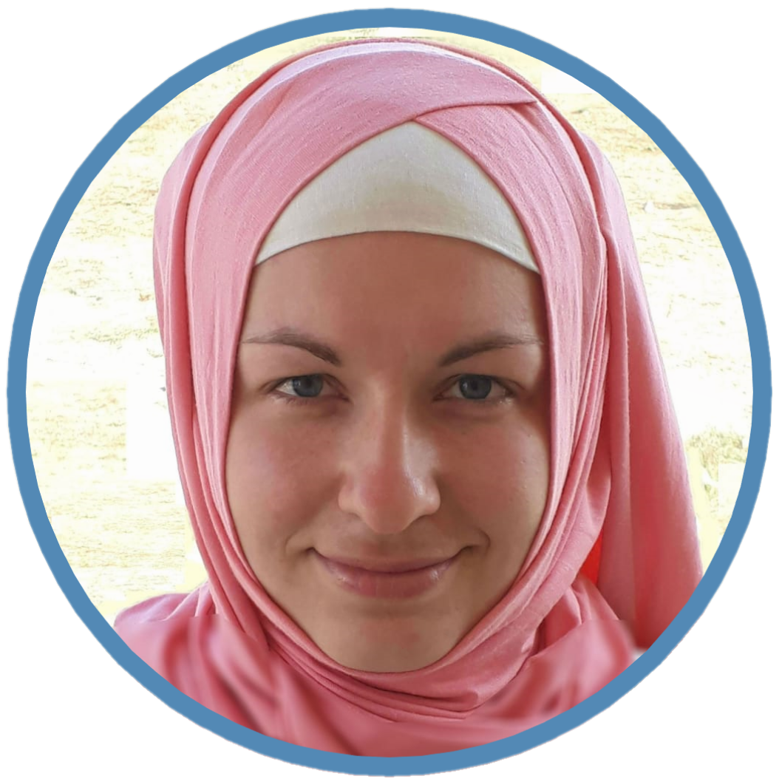   |  |  | Yulia  Demir
Summary  Looking for a junior or trainee position. Participated in student projects related to the development of a system for modeling physical processes.  Bachelor's degree in progress.  Contact  PHONE:  +90 543 877 89 00  EMAIL:  Nightelfin91@gmail.com  TELEGRAM:  @Yulia_abla |  |  | EDUCATION  Anadolu University (Eskisehir)  Economy  In progress, 2026  Akdeniz University (Antalya)  Physics and Astronomy  Incomplete higher education  MEPHI (Moscow)  Computer Science and Management Processes  Incomplete higher education  HARD SKILLS  Well conversant with programming in JavaScript, HTML/CSS.  - Well familiar with Microsoft Office Tools.  - Conversant with Auto-Cad, С++, MySQL, Java.  SOFT SKILLS  - Team Player  - Active Learning  - Detail Oriented  - Stress Management  - Openness to Feedback  - Punctuality  - Prioritization and organizational skills  LANGUAGES  - English B1  - Turkish C1  - Russian C2

